The World's Columbian Exposition

Welcome to the great World's Columbian Exposition of 1893. Millions of American and foreign visitors packed the Fairgrounds from May to October, braving rain and mud, blistering heat, and the occasional pickpocket. They covered the 633 acres of Jackson Park in two to four days, some staying for a week or even more. The Fair was so vast and complex that an excellent starting point to understanding its messages, meanings, and legacy is a "virtual tour" of its physical landscape.
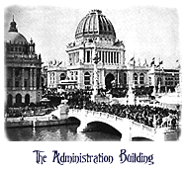
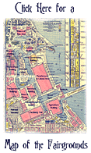
In general, guests arrived on the Fairgrounds in one of three ways: through the street entrance on the Midway (now the University of Chicago), on the Lake Michigan pier to the east, or the huge railroad terminus to the southwest. While many took the scenic route by steamship from downtown Chicago and landed on the pier, most arrived by train. After paying their 50 cent admission fee for the day, visitors were greeted with an overwhelming cacophony of voices, music, and crowds. The first view Fairgoers experienced once inside the grounds was equally overwhelming--the Administration building. The 55,000 square foot domed building was designed by Richard M. Hunt of New York, and served as the headquarters for the chief officers of the Exposition. It also served as the chief introduction to the main architectural theme of the 14 "great" buildings of the Fair--the Beaux-Arts style. Daniel Burnham and the Board of Architects sought a uniform architectural style for the main showpieces of the Fair, and utilized their Beaux-Arts training to this end. All of the main buildings were of a uniform cornice height, geometrically logical, and covered in the same white staff (stucco), producing a homogenous yet somehow magnificent grouping of buildings.
Visitors inevitably wandered past the Administration Building to the Court of Honor proper. The centerpiece of the Court was the Grand Basin, a large reflecting pool containing the elaborate MacMonnies Fountain and the immense gilded statue of the Republic. These sculptural elements were framed to the east by the Peristyle, an arch placed to balance the grouping of exhibition buildings to the north and south of the basin, and as an entrance point for visitors arriving from the pier. As the sound of the Columbian Chorus or Orchestra drifted in from the lakefront, the guests attempted to ignore the very Chicago smell of the Fair's stock pavilions nearby and make their foray into the first of 200 buildings on the grounds: the Machinery Building.
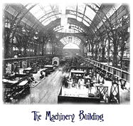
Machinery Hall, designed by the Boston firm Peabody & Stearns at a cost of $1.2 million, was the first introduction to a strange dichotomy of the Fair--the classic and uniform facades of the main buildings gave way to an interior reminiscent of a combination of Marshall Field's department store and an airplane hangar. The interiors were generally one large room (in this case, 435,500 square feet) with high ceilings, crammed to the walls with exhibits. The Machinery Building not only contained exhibits such as Whitney's cotton gin, sewing machines, and the world's largest conveyor belt, but also the Fair's power plant, with 43 steam engines and 127 dynamos providing electricity for the Fair.
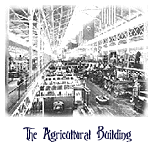
Once visitors were introduced to the physical dimension of the Fair and its contents through the Grand Basin and the Machinery Building, they were ready for some serious sightseeing. The Agricultural Building, a 400,000 square foot product of New York's McKim, Mead & White, was the epitome of the excess of exhibits. Not only were there weather stations and farm building models on display, there were animals, machines, tools, and 100 discrete tobacco exhibits. Ostriches from the Cape Colony were found near a map of the United States made entirely of pickles and not one but two Liberty Bell models--one in wheat, oats, and rye, and one entirely in oranges. The Schlitz Brewery had a very popular booth, and Canada's "Monster Cheese" (22,000 pounds) vied for attention with the Egyptian cigarette booth.
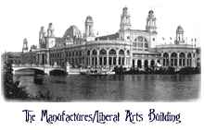
By this point, undoubtedly, visitors were exhausted not only by the size of the exhibit spaces, but by the sheer number of exhibits presented. As they walked back out into the glare of the Court of Honor, their next thought was: lunch. Concessionaires selling boxed lunches, hamburgers, and the newly introduced carbonated soda were scattered throughout the Fairgrounds, as were scores of sit-down restaurants--including the New England Clam Bake restaurant near the Lake Front, serving clam chowder, baked beans, and pumpkin pie. Revived by the lunch and the brisk lake wind, visitors pressed on northward. Obviously, visitors thought they had seen it all--the range and number of exhibits was amazing. But, as they were soon to discover, they were in for a surprise. Passing before the Peristyle as they headed north, Fairgoers were greeted by the enormous expanse of the Manufactures and Liberal Arts building. Covering over 11 acres of exhibition space, the George Post-designed building brought together exhibitors from all around the world. There was a dual purpose to this building, as its name implies. Manufactured goods were displayed, with price tags for comparative shopping, next to exhibits which could roughly be categorized as being part of the humanities. Remington typewriters and Tiffany & Co. stained glass were under the same exhibition roof with the University of Chicago's 70-ton Yerkes telescope and Bach's clavichord. Goods pavilions, which contained everything from clothes to phonographs, were erected within the building by America, Germany, Austria, China, Japan, France, Russia, and England. Furniture from the palace of the King of Bavaria was displayed, as was the manuscript of Lincoln's Inaugural address and Mozart's spinet. This was the most eclectic of exhibits, combining goods for sale with items of historical and artistic interest.

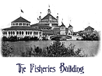
The Court of Honor gave way on the north to the U.S. Government building, a small structure containing displays by the departments of War, State, Treasury, Interior, Justice, Agriculture, and Post Office. Exhibits on George Washington, carrier pigeons, international currency, and a huge California redwood tree were the highlights of this building, often ignored by visitors on their way to the Fisheries Building. Designed by Henry Ives Cobb of Chicago, the Fisheries' two acres of exhibition space was well balanced with the Olmsted-designed lagoon to the west and Lake Michigan to the east. The highlight of the display was widely agreed to be the double row of floor-to-ceiling aquaria, filled with hundreds of species of fresh and salt water fish. The building was also noteworthy by its departure from the Beaux-Arts form of the Court of Honor, focusing instead on walls of delicate glass and multicolored flags.
Once guests emerged into the late afternoon sun on their first day, many decided to take a break and return for more sightseeing the next morning. Taking the elevated railway from the Lake Front to the railroad station, visitors left the Exposition, often to see Buffalo Bill's Wild West Show just outside the fairgrounds, and prepare for the next day's amusement-- Part Two of the Official Tour.

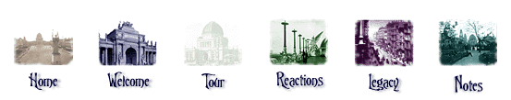
~
Home ~ Welcome ~ Tour the Fair ~ Reactions to the Fair ~ The Legacy of the Fair ~ Notes and Further Reading

Copyright 1996 Julie K. Rose

